Deploying a Laravel project from GitHub to AWS
Deploying a Laravel project from GitHub to AWS involves several steps, including setting up an EC2 instance, configuring a web server, setting up a database, and deploying the Laravel project.

Step 1: Launch an EC2 Instance
- Sign in to AWS and go to the EC2 service.
- Click Launch Instance and configure:
  - Choose an Amazon Machine Image (AMI): Select Ubuntu 22.04 (or any LTS version).
  - Instance Type: Select t2.micro (free-tier eligible).
  - Key Pair: Create/download a key pair for SSH access.
  - Security Group: Open ports 22 (SSH), 80 (HTTP), and 443 (HTTPS).
  - Storage: Allocate at least 10GB.
- Click Launch and wait for the instance to start.

Step 2: Connect to EC2
- Open a terminal and SSH into the instance:
ssh -i your-key.pem ubuntu@your-ec2-public-ip
Or
You can also use the AWS terminal by navigating to the specific instance and clicking the 'Connect' button. This will open a terminal where you can run commands.
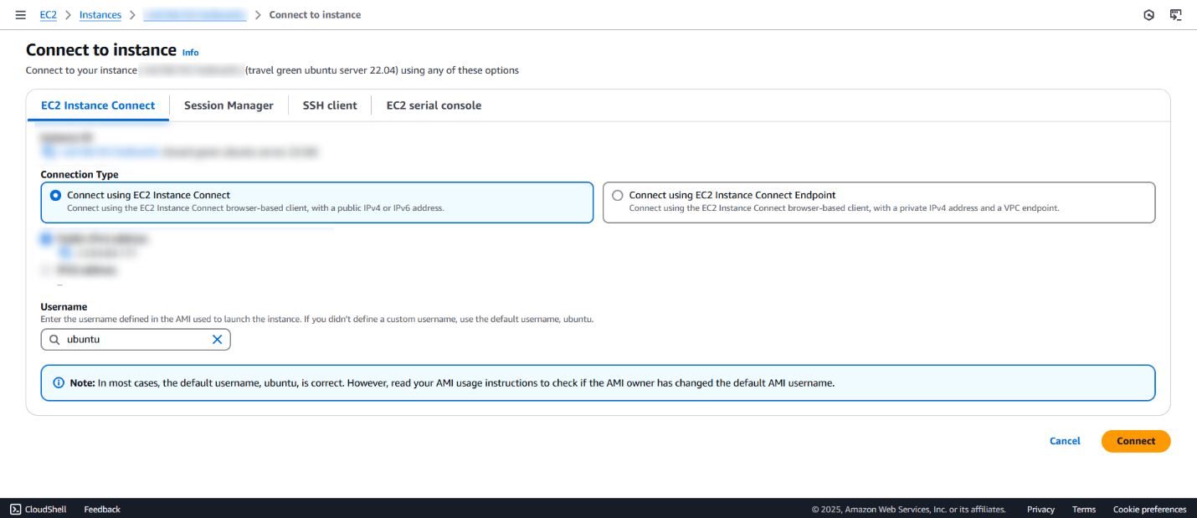
Step 3: Install Required Packages
1. Update the system:
sudo apt update && sudo apt upgrade -y
2. Install Nginx
sudo apt install nginx unzip curl software-properties-common -y
service nginx status
3. Install PHP and required extensions:
- Add the PHP repository:
sudo add-apt-repository ppa:ondrej/php -y
sudo apt update
sudo apt install php8.2 php8.2-cli php8.2-fpm php8.2-mysql php8.2-mbstring php8.2-xml php8.2-curl php8.2-zip php8.2-bcmath -y
- Install Composer:
curl -sS https://getcomposer.org/installer | php
sudo mv composer.phar /usr/local/bin/composer
- Install MySQL:
sudo apt install mysql-server -y
sudo mysql_secure_installation
- Confirm database service is installed
sudo systemctl status mysql
- Create a new database
sudo mysql
CREATE DATABASE database_name;
SHOW DATABASES;
- Create a new MySQL
CREATE USER 'demoAdmin'@'localhost' IDENTIFIED BY 'your password’;

Next, we need to grant the demoAdmin user privileges to manage the demo database. The following command will grant all privileges to all tables (*) within the demo database:
GRANT ALL PRIVILEGES ON demo . * TO 'demoAdmin'@'localhost';
Step 4: Clone Laravel Project from GitHub
- Install Git:
sudo apt install git -y
- Navigate to /var/www/html and clone your Laravel project without folder name:
sudo git clone https://github.com/your-repo.git your-project
- Set permissions:
sudo chown -R www-data:www-data /var/www/html/your-project
sudo chmod -R 775 /var/www/html/your-project

Step 5: Configure Laravel
- Navigate to your project folder:
cd /var/www/html/your-project
- Install dependencies:
composer install
If a platform error occurs, use the following one instead.
composer install --ignore-platform-reqs
- Set up environment variables:
cp .env.example .env
- Generate app key:
php artisan key:generate
- Set permissions for storage and bootstrap:
sudo chmod -R 777 storage bootstrap/cache
- Update .env:
DB_CONNECTION=mysql
DB_HOST=127.0.0.1
DB_PORT=3306
DB_DATABASE= database_name
DB_USERNAME=database_user
DB_PASSWORD=database_password

- Run migrations:
php artisan migrate –force

Step 7: Configure Nginx
- Open default file
sudo nano /etc/nginx/sites-available/default
- Add public after html
root /var/www/html/public;
- Add index.php to the list if you are using PHP
index index.html index.htm index.php index.nginx-debian.html;
- Server name should be the Public IPv4 address from aws instance
server_name Public IPv4 address from aws;
- Add the following lines:
location / {
try_files $uri $uri/ /index.php?$query_string;
}
location ~ \.php$ {
try_files $uri =404;
fastcgi_split_path_info ^(.+\.php)(/.+)$;
fastcgi_index index.php;
fastcgi_pass unix:/var/run/php/php8.2-fpm.sock;
include fastcgi_params;
fastcgi_param PATH_INFO $fastcgi_path_info;
fastcgi_param SCRIPT_FILENAME $document_root$fastcgi_script_name;
}
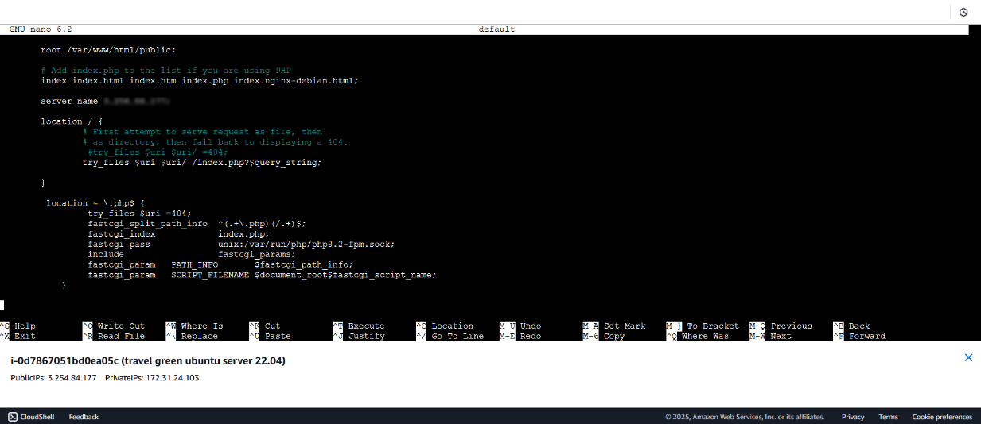
Please refer to the attached image for reference

Step 11: Restart Services and Test
sudo systemctl restart nginx

Access http://yourdomain.com or http://your-ec2-public-ip.

